Experiment-33

School management wants to validate DOB of all students. Write a LEX program to implement it.
Code:
%{
#include <stdio.h>
%}
%%
(0[1-9]|[12][0-9]|3[01])[-/.](0[1-9]|1[0-2])[-/.](19[0-9]{2}|20[0-9]{2}) {
printf("Valid DOB: %s\n", yytext);
}
[^\n]+ { printf("Invalid DOB: %s\n", yytext); }
\n ;
%%
int main(){ yylex(); return 0; } int yywrap(){ return 1; } Output:
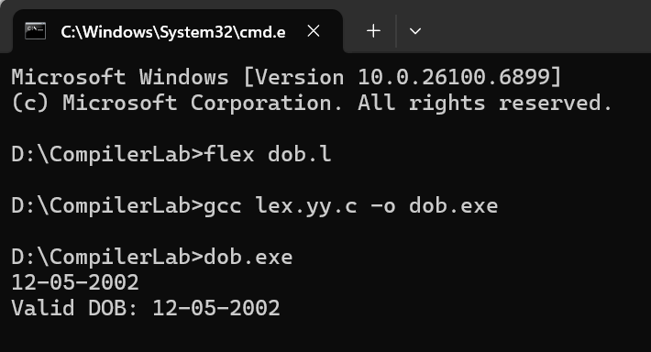

Experiment-34
Write a LEX program to check whether the given input is digit or not. Code:
%{
#include <stdio.h>
%}
%%
[0-9] { printf("It is a Digit: %s\n", yytext); }
.|\n { printf("Not a Digit: %s\n", yytext); }
%%
int main(){ yylex(); return 0; } int yywrap(){ return 1; } Output:
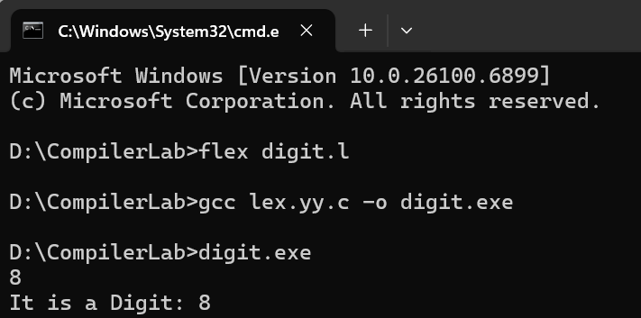

Experiment-35
A School student was asked to do basic mathematical operations. Implement a LEX program to implement the same.
Code:
%{
#include <stdio.h> #include <stdlib.h>
%}
NUMBER [0-9]+
%%
{NUMBER}"+"{NUMBER} { int a,b; sscanf(yytext,"%d+%d",&a,&b); printf("Addition:
%d\n", a+b); }
{NUMBER}"-"{NUMBER} { int a,b; sscanf(yytext,"%d-%d",&a,&b); printf("Subtraction:
%d\n", a-b); }
{NUMBER}"*"{NUMBER} { int a,b; sscanf(yytext,"%d*%d",&a,&b); printf("Multiplication: %d\n", a*b); }
{NUMBER}"/"{NUMBER} { int a,b; sscanf(yytext,"%d/%d",&a,&b); if(b!=0) printf("Division: %.2f\n", (float)a/b); else printf("Division by zero\n"); }
[ \t\n]+ ;
. ;
%%
int main(){ yylex(); return 0; } int yywrap(){ return 1; } Output:
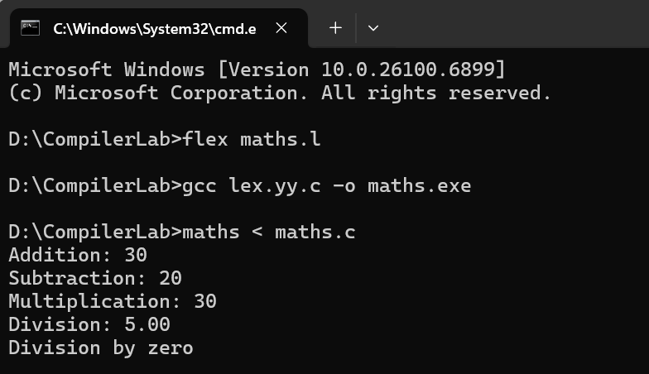

Experiment-36

Write a LEX program to accept string starting with vowel. Code:
%{
#include <stdio.h>
%}
%%
[AEIOUaeiou][a-zA-Z]* { printf("Valid: %s\n", yytext); } [a-zA-Z]+ { printf("Invalid: %s\n", yytext); }
.|\n ;
%%
int main(){ yylex(); return 0; } int yywrap(){ return 1; } Output:
